CHAPTER 3. TEST DESIGN & EXECUTION

3.1. Test Scenarios
This chapter presents how the test scenarios and test cases were designed for the Online Sales Management System and how the resulting execution evidence supports the final submission. The design phase was based on real system modules, route behavior, role boundaries, validation rules, and business-risk areas identified through source inspection and local execution.
The scenario set was intentionally broader than the minimum number of test cases required by the course. This allowed the team to split ownership cleanly across members, cover both positive and negative flows, and preserve enough business-rule depth to support defect discovery and traceability.

3.1.1. UI test scenarios
The UI scenario design covers the administrative interface and the public product catalog. Administrative scenarios dominate the scope because the highest-risk workflows of the system exist in secured modules such as authentication, permissions, purchases, invoices, stock, reports, and product import. Public UI scenarios were included to verify search, sorting, filtering, and product-detail behavior.
Based on the current scenario matrix, the project contains 33 Admin UI scenarios and 3 Public UI scenarios. These scenarios were then split into detailed executable UI test cases with non-overlapping ownership.
Table 3.1. UI scenario distribution by interface
Interface | Scenario count | Main focus
Admin UI | 33 | Authentication, permissions, CRUD, purchases, invoices, stock, reports, import
Public UI | 3 | Search, filtering, sorting, and product details
Total UI scenarios | 36 | Complete UI scenario coverage

Table 3.2. Representative UI scenario groups
Module | Representative scenario focus | Risk level
Authentication | Valid login, invalid login, inactive-account blocking | Critical
Permissions | Role-based denial and module visibility | Critical
Products / Import | Validation, duplicate handling, preview and confirm behavior | Critical
Purchases | Draft creation, validation, receiving, cancellation rules | Critical
Invoices | Creation, payment transition, cancellation, stock-sensitive logic | Critical
Stock / Reports | Visibility, filtering, export-source verification | High
Public Catalog | Search, filter, sort, and product details | Medium

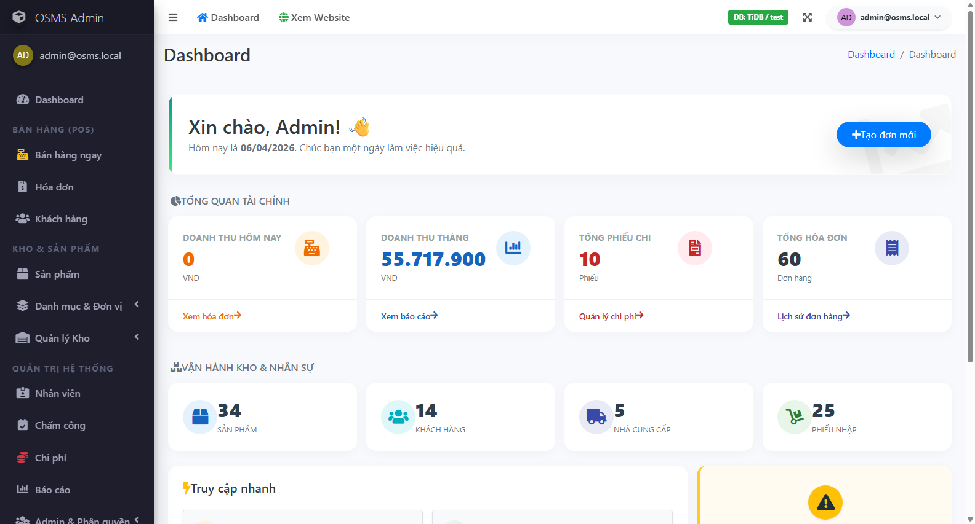
Figure 3.1. Example UI execution evidence for a successful authentication scenario.

3.1.2. API test scenarios
API scenario design focused on the real endpoints exposed by the project rather than hypothetical or undocumented services. The scenario set covers the Health API and the public Catalog API. API scenarios were selected to verify service availability, response structure, query handling, detail retrieval, and invalid-parameter behavior.
The current scenario baseline contains 6 API scenarios, which were expanded into 19 detailed API test cases in the dedicated workbook. This split allowed the team to test more than one parameter combination under a single high-level scenario when needed.
Table 3.3. API scenario coverage
API scenario area | Scenario focus | Representative endpoint
Health API | Service availability and payload structure | GET /api/v1/health
Catalog list | Pagination, search, filter, and sort behavior | GET /api/v1/catalog/products
Catalog detail | Valid ID and not-found behavior | GET /api/v1/catalog/products/{id}
Catalog metadata | Trending and filter-data retrieval | GET /api/v1/catalog/trending and /filters
Validation handling | Unsupported or invalid query combinations | Catalog endpoints with invalid parameters

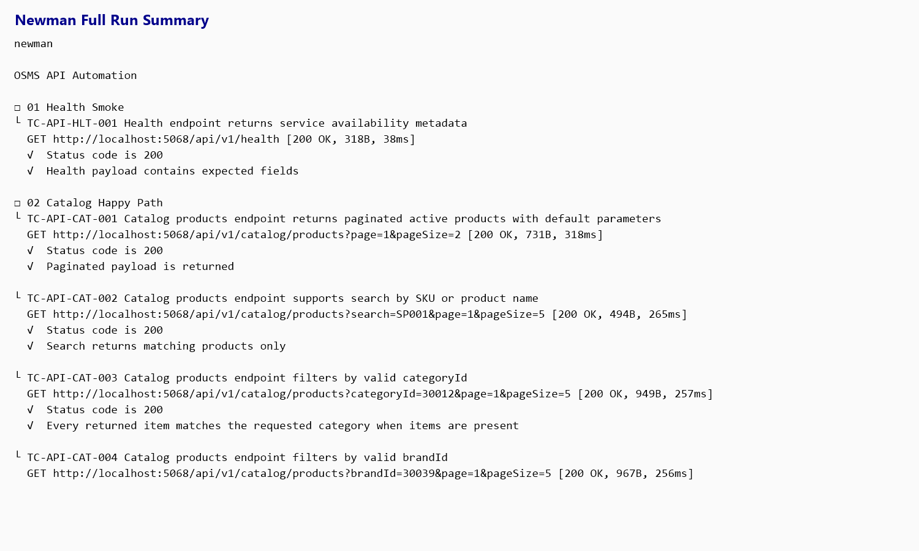
Figure 3.2. API scenario execution evidence produced by the Newman full-run output.

3.1.3. Edge cases and exception scenarios
Edge cases and exception scenarios were intentionally included to prevent the design from being limited to happy-path verification. These scenarios are important because the rubric rewards logical depth, error handling, and the ability to identify hidden business-rule defects.
• inactive-account login despite otherwise valid credentials
• role-based access attempts to secured modules
• duplicate SKU and invalid numeric values in product management
• non-xlsx and malformed uploads for product import
• expired or missing preview state during import confirmation
• purchase creation with missing supplier or empty item list
• invoice creation with insufficient stock or invalid posted state
• invoice cancellation and payment transitions under sensitive business states
• unsupported sort and invalid query combinations in API requests
Table 3.4. Representative edge and exception scenarios
Scenario ID | Area | Exception / edge focus | Why it matters
SCN-AUTH-003 | Authentication | Inactive account login attempt | Prevents unauthorized account reuse
SCN-GOV-001 | Permissions | Sales role opens restricted module | Verifies authorization boundaries
SCN-PROD-006 | Product Import | Invalid upload type or malformed workbook | Protects the system from invalid bulk data input
SCN-PROD-007 | Product Import | Preview-confirm lifecycle issues | Targets high-risk cache and state behavior
SCN-PUR-002 | Purchases | Missing supplier or missing item list | Protects transaction integrity
SCN-INV-003 | Invoices | Server-side price and transaction safety | Targets hidden business-rule and security risk
SCN-INV-006 | Invoices | Cancellation and stock-return logic | Directly affects inventory consistency
SCN-API-003 | Catalog API | Invalid sort / page / page-size validation | Protects API robustness and predictable error handling

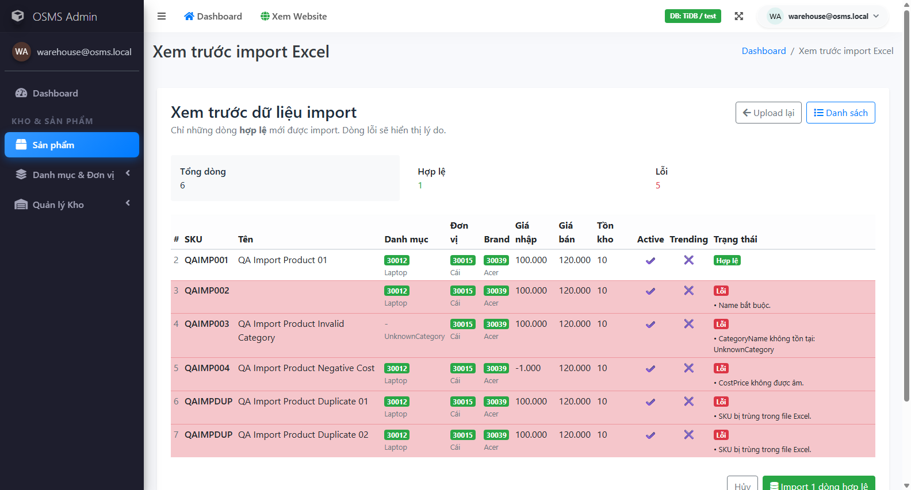
Figure 3.3. Example edge-case evidence from the product import preview validation flow.

3.2. Test Case Specification
After the scenario set was stabilized, each scenario was expanded into detailed executable test cases. The final design uses separate UI and API workbooks, with consistent fields for identifiers, preconditions, test data, steps, expected results, actual results, ownership, and evidence references. This structure supports both execution discipline and post-execution traceability.

3.2.1. UI test cases
The UI workbook currently contains 44 detailed UI test cases. These cases cover administrative and public-user flows, and every row includes a direct owner assignment, explicit preconditions, concise steps, expected result, actual result, final status, and evidence reference. The workbook therefore satisfies the course requirement for industry-standard testcase formatting.
Table 3.5. Sample UI test case specification (positive case)
Field | Value
Test Case ID | TC-UI-AUTH-001
Scenario ID | SCN-AUTH-001
Title | Login succeeds with valid admin account
Module | Authentication
Owner | Hoang Van Thien
Preconditions | Application is running locally and seeded admin account exists.
Test Data | Email=admin@osms.local; Password=Admin@12345
Steps | 1 Open /Admin/Auth/Login; 2 Enter admin email; 3 Enter valid password; 4 Click Sign in.
Expected Result | User is redirected to the admin area dashboard; authenticated session is established; no validation error is shown.
Actual Result | Valid admin login reached the admin dashboard successfully in both the focused Chrome rerun and a secondary Edge smoke rerun on 2026-04-11.
Status | Pass
Evidence / Note | TestResults/Evidence/UI/automation/20260406_053930_TC-UI-AUTH-001-success.png ; TestResults/Evidence/UI/automation/20260411_143741_TC-UI-AUTH-001-success.png ; TestResults/RunnerOutput/UI/auth-permission-rerun.trx ; TestResults/RunnerOutput/UI/edge-auth-smoke.trx ; Videos/OSMS-Automation-Demo.mp4

Table 3.6. Sample UI test case specification (defect-focused case)
Field | Value
Test Case ID | TC-UI-INV-001
Scenario ID | SCN-INV-001
Title | Create invoice successfully for walk-in sale with unpaid status
Module | Invoices
Owner | Hoang Van Thien
Preconditions | Sales or admin user is logged in; at least one active product has stock greater than 0.
Test Data | Customer=None; Product=Any active in-stock product; Qty=1; PaidAmount=0
Steps | 1 Log in as sales or admin; 2 Open /Admin/Invoices/Create; 3 Leave customer empty for walk-in sale or choose a valid customer; 4 Select one active in-stock product; 5 Set quantity to 1; 6 Set paid amount to 0; 7 Submit the invoice.
Expected Result | Invoice is created successfully; details page is shown; invoice status is Unpaid; stock is reduced by the sold quantity.
Actual Result | Submitting a valid walk-in invoice returned to the Create page with the toast message Failed to create invoice. Please check data and try again. Server log confirms InvalidOperationException caused by a user-initiated transaction with MySqlRetryingExecutionStrategy in InvoicesController.Create line 145. A focused rerun on 2026-04-11 still failed before reaching the details page, so the defect remains reproducible.
Status | Fail
Evidence / Note | TestResults/Evidence/UI/automation/20260406_053902_TC-UI-INV-001-failure.png ; TestResults/Evidence/UI/automation/20260411_143458_TC-UI-INV-001-failure.png ; TestResults/RunnerOutput/UI/invoice-rerun.trx ; TestResults/RunnerOutput/UI/postfix-retest-inv-001.trx ; TestResults/Defects/OSMS-Defect-Log.xlsx ; https://github.com/Alucard30Dec/Online-Sales-Management-System/issues/1

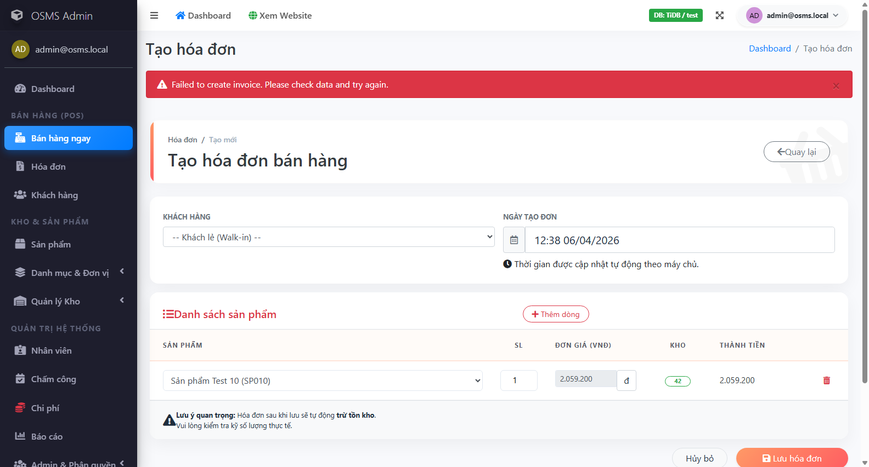
Figure 3.4. Defect-focused UI execution evidence for invoice creation failure.

3.2.2. API test cases
The API workbook contains 19 API test cases derived from 6 high-level API scenarios. The API cases use the same traceability principle as the UI cases, but add endpoint-specific fields such as method, authentication requirement, expected status code, and expected response body.
Table 3.7. Sample API test case specification
Field | Value
Test Case ID | TC-API-HLT-001
Scenario ID | SCN-API-001
Title | Health endpoint returns service availability metadata
Module | Health API
Endpoint | /api/v1/health
Method | GET
Auth Requirement | None
Test Data | Base URL=http://localhost:5068
Steps | 1 Ensure the application is running locally; 2 Send GET request to http://localhost:5068/api/v1/health using Postman or browser.
Expected Status Code | 200
Expected Body | JSON response contains non-empty fields for status, service, serverTimeUtc, and version; status value is ok.
Actual Result | Health endpoint returned 200 OK and all Newman assertions for status, service, serverTimeUtc, and version passed in the full collection rerun.
Status | Pass
Evidence / Note | Primary evidence: TestResults/Evidence/API/newman-full-run.txt ; Secondary artifact: TestResults/RunnerOutput/API/newman-results.xml

3.2.3. Test case allocation by member
Ownership allocation was used to satisfy the requirement that each member contributes at least ten non-overlapping test cases. UI cases were distributed by module cluster, while API cases were executed as a shared QA-team artifact due to their smaller surface and automation-centric nature.
Table 3.8. Test case allocation by member
Owner | Assigned UI cases | Allocation note
Hoang Van Thien | 17 | Authentication, permissions, admin, invoices, reports, and partial public-catalog coverage
Nguyen Thanh Dat | 13 | Customers, suppliers, purchases, and partial stock coverage
Le Quang Duy | 14 | Products, product import, public catalog, and partial stock coverage
QA Team | 19 | Shared ownership for API execution and automation evidence

This allocation keeps module ownership visible while preserving a shared quality baseline across the final package. It also supports defense readiness because each member can explain both the rationale and the execution evidence of the areas they owned.

3.2.4. Execution evidence summary
The execution baseline is fully recorded in the final-results workbook and linked evidence files. Every designed test case in the current baseline has an execution result, and each fail case is traceable to evidence and defect records.
Table 3.9. Execution evidence summary
Metric | Value
Total executed test cases | 63
Pass | 56
Fail | 7
Admin UI cases | 41
Public UI cases | 3
API cases | 19
Execution completeness | 100% of the current baseline

Table 3.10. Execution evidence types
Evidence type | Purpose | Representative artifact
UI screenshots | Visual proof of page state and result outcome | Admin login, import preview, invoice failure screenshots
TRX runner output | Execution trace for focused UI automation reruns | UI rerun files under TestResults/RunnerOutput/UI
Newman TXT and XML | Exportable API automation proof | newman-full-run.txt and newman-results.xml
GitHub Issues | Professional bug-management evidence | Live issues for the four confirmed defects
Automation video | Presentation-ready execution walkthrough | OSMS-Automation-Demo.mp4

